- SPR-42 is approved for the following work: Install FOUR additional PIV readers to increase the safety of staff and patients on Inpatient MH-3B. This safety issue was identified during MHEOCC rounds.
  - Location for PIV readers include entry door to 3B-149 (Day Room), entry door from nurses station to 3B-165 (Ante Room), exit door from nurses station to 3B-C3-20 (corridor), exit door from nurses station to 3B-C3-19 (corridor). Locations are shown with red X’s below.
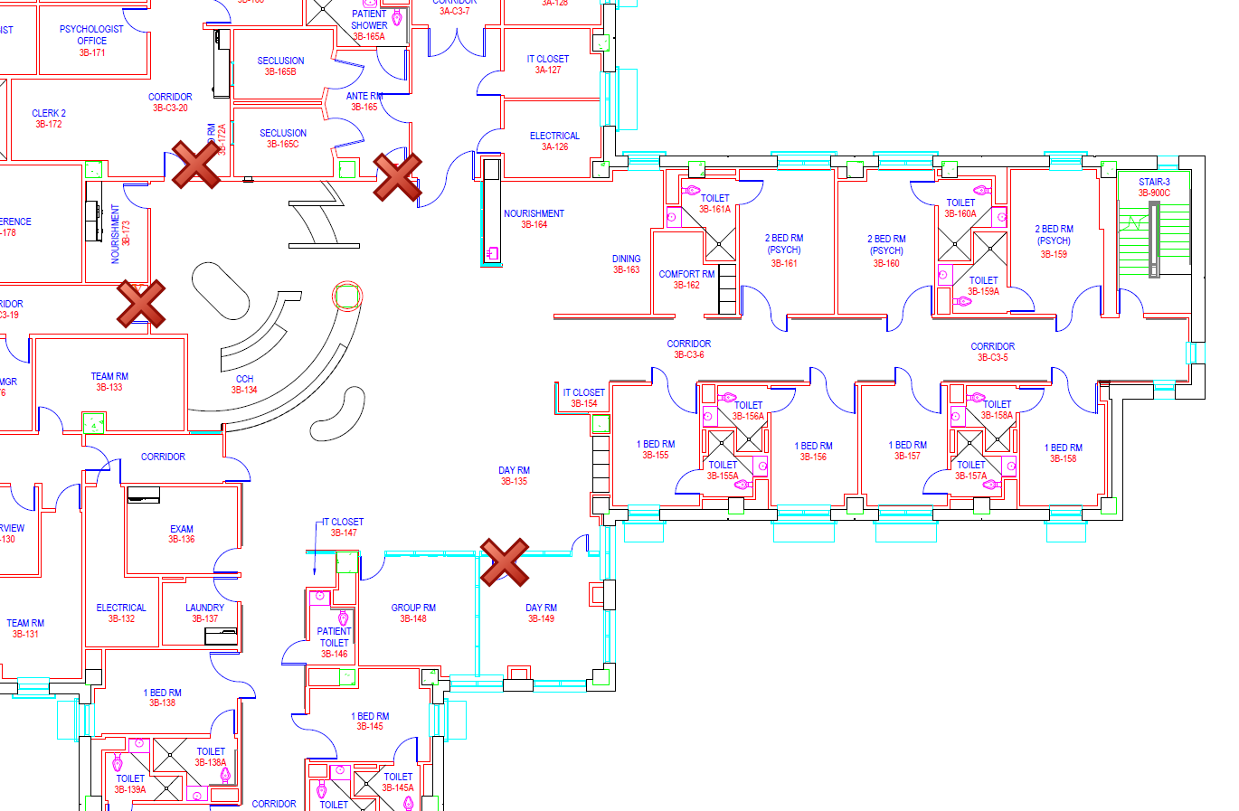

- SPR-44 is approved for the following work: Install PIV readers to automatic doors that lead into the treatment area. Currently, patients are able to walk into restricted area and this needs to be badged to protect patient privacy.
  - Location for PIV reader is the door between Corridor C3 and X-Ray 130, circled below.
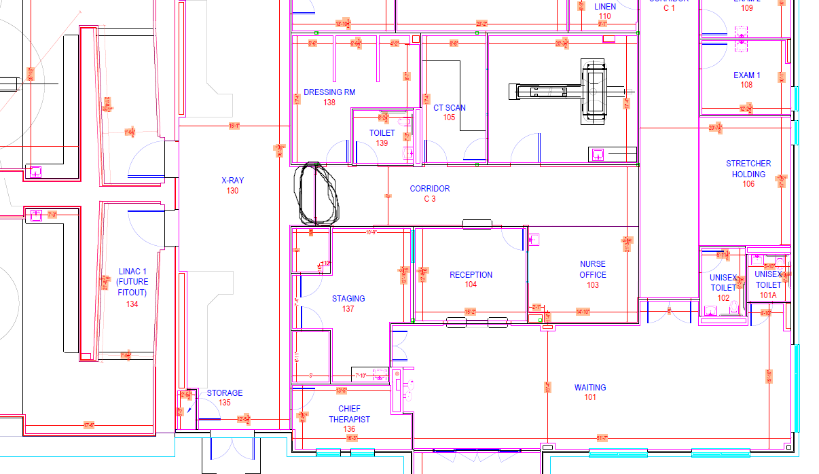

- SPR-64 is approved for the following work: : Install THREE additional PIV readers to increase the safety of staff and patients on Inpatient MH-3A, for new women’s program. This measure will increase the safety of Project Lighthouse space as well.
  - Location for PIV readers include entry door to 3A-171 (Day Room), entry door from nurses station to 3A-155 (Ante Room), door between corridors 3A-C3-25 & 3B-C3-26. Locations are shown with red X’s below.
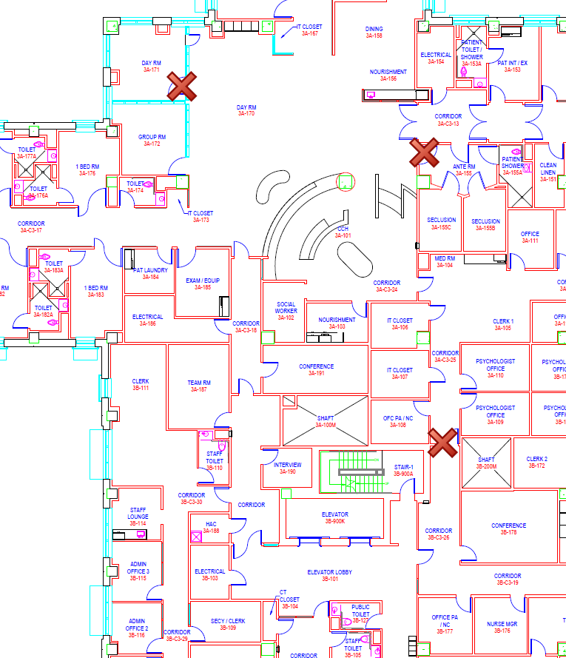

- SPR-76 is approved for the following work: Install PIV reader for door 1B-178 in bldg. 111. This is where the Mass Casualty triage carts and decon equipment will be held, and the ED and HERT team will need access.
  - Location for PIV reader is door 1B-178, shown below.
- 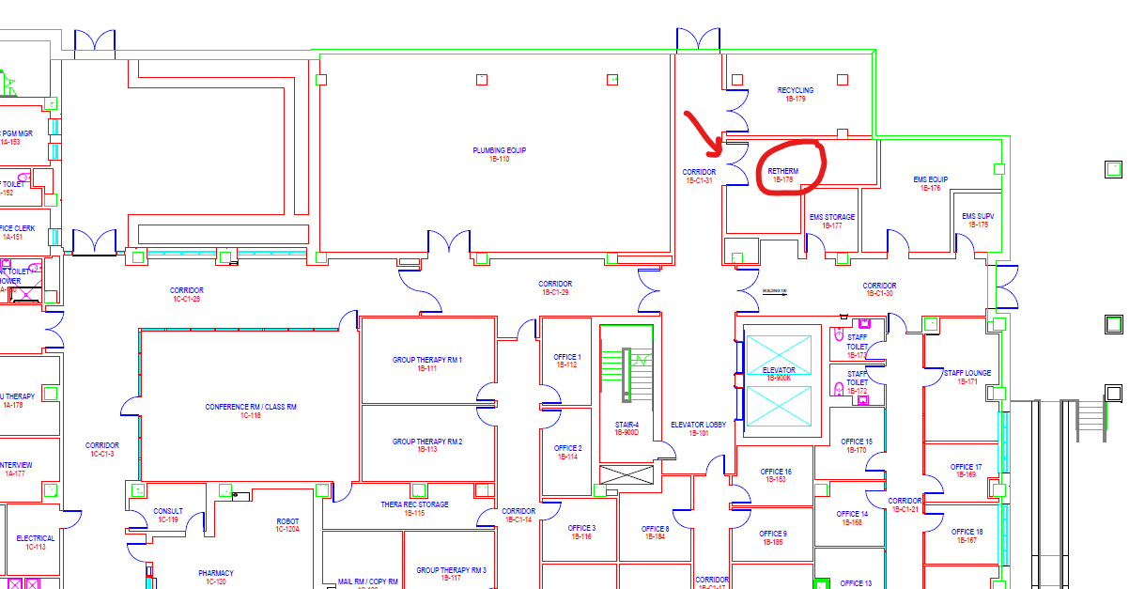

- SPR-82 is approved for the following work: Install PIV readers for both main kitchen entry doors.
  - Location for PIV readers are, shown below, circled in red.



